
SRM Institute of Science and Technology
Mode of Exam
OFFLINE
College of Engineering and Technology
School of Computing
DEPARTMENT OF COMPUTING TECHNOLOGIES
SRM Nagar, Kattankulathur – 603203, Chengalpattu District, Tamilnadu
Academic Year: 2022-2023 (ODD)
Test: CLAT-3 SET-D Date: 02.11.2023
Course Code & Title: 18CSE453T NETWORK ROUTING ALGORITHMS Duration: 8AM- 9.40AM
Year & Sem: III / IV & V / VII Max. Marks: 50

Course Articulation Matrix: (to be placed)
S.No. | Course Outcome | PO1 | PO2 | PO3 | PO4 | PO5 | PO6 | PO7 | PO8 | PO9 | PO10 | PO11 | PO12
1 | CO1 | H |  | M |  |  |  |  |  |  |  |  | M
2 | CO2 |  | M | L |  | H
3 | CO3 |  | H | L | H
4 | CO4 | M | H | H
5 | CO5 |  | H |  | H | H
6 | CO6. |  | H |  | H | H

Part - A
( 10 x 1 =10 Marks)
Instructions: Answer all
Q. No | Question | Marks | BL | CO | PO | PI Code
1 | Which algorithm used by EIGRP for selecting and maintaining the best path to each remote network ?  - Single  - DUAL  - Dijikstra  - Bellman-Ford | 1 | 1 | 4 | 2 | 1.4.1
2 | Which one of the following, narrates one routing network or a group of networks would operate under the control of one enterprise?  a. Border Gateway Protocol (BGP)  b. Exterior Gateway Protocol (EGP)  c. Inter Domain Routing Protocol (IDRP)  d. Intermediate System to Intermediate System (IS-  IS) | 1 | 1 | 4 | 1 | 1.4.1
3 | Which packet is NOT an OSPF packet type?  - LSU  - LSR  - DBD  - Query | 1 | 1 | 4 | 1 | 1.4.1
4 | What type of address where Routing Information Protocol (RIP) V2’s routing table is being shared on the network?  a. Unicast address  b. Multicast address  c. Broadcast address  d. Anycast address | 1 | 1 | 4 | 1 | 1.4.1
5 | Which one of the following options is correct, when imparts with the metric of a directly connected route?  a. It has a cost equal to 0  b. It has a cost equal to 1  c. It has a cost equal to infinity  d. It has a cost equal to negative value | 1 | 2 | 4 | 2 | 2.5.1
6 | Select the protocol that uses hierarchical network topology?  - Cluster-Head Gateway Switch Routing protocol  - CEDAR  - FORP  - ABR | 1 | 1 | 5 | 1 | 1.4.1
7 | Which protocol would have the responsibilities of forwarding of a route request?  a. Intra zone Routing Protocol (IARP)  b. Inter zone Routing Protocol (IERP)  c. Broadcast Resolution Protocol (BRP)  d. Neighbor Discovery Protocol (NDP) | 1 | 1 | 5 | 1 | 1.4.1
8 | Mobile ad-hod network lacks  - Mobile nodes  - Dynamically changing topology  - Infrastructure  - Topology | 1 | 2 | 5 | 2 | 2.6.4
9 | Which one of the following fields that do with discard multiple copies of the same Route Request?  a. source identifier  b. destination identifier  c. broadcast identifier  d. destination sequence number | 1 | 1 | 5 | 1 | 1.4.1
10 | What is the distance, that would be specified in the routing table at node 5 with respect to destination 0 and next hop 2?  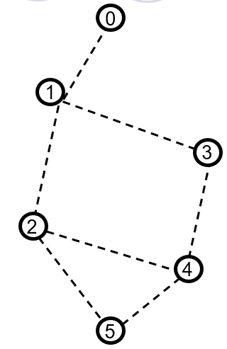  a. 1  b. 2  c. 3  d. 4 | 1 | 3 | 5 | 3 | 3.7.1
Part – B
( 4 x 10 = 40 Marks)
Instructions: Answer ALL
11.a | 1.Compare and contrast the packet format of RIPv1 and RIPv2 with proper explanation  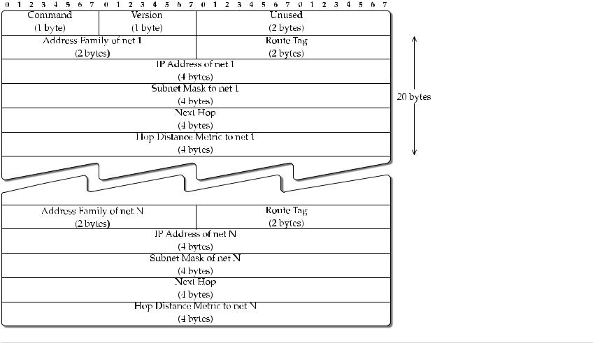  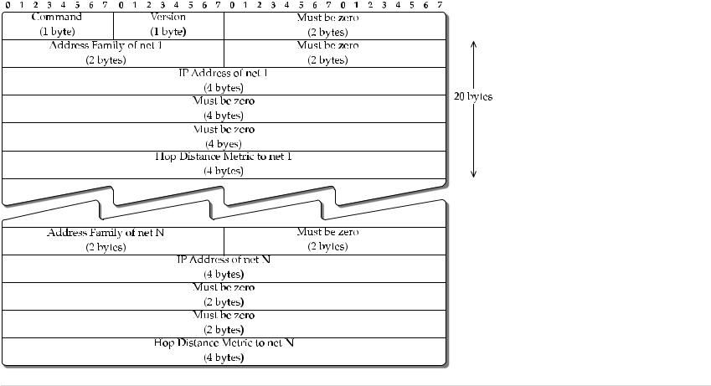 | 10 | 1 | 4 | 1 | 1.4.1
 | (OR)
11.b | Explain the Packet format of BGP with neat diagram  IBGP:  BGP is also used to set up peer (neighbor) connections between two BGP speakers within an AS, known as internal BGP (IBGP) speakers.  - Rule 1: A BGP speaker can advertise IP prefixes it has learned from an EBGP speaker to a neighboring  IBGP speaker; similarly, a BGP speaker can advertise IP prefixes it has learned from an IBGP speaker to an EBGP speaker.  - Rule 2: An IBGP speaker cannot advertise IP prefixes it has learned from an IBGP speaker to another neighboring IBGP speaker.  EBGP:  Connections between two BGP speakers using different AS, known as external BGP (IBGP) speakers.  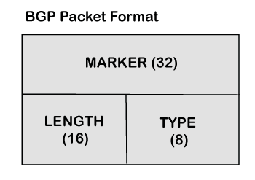  - Marker: It is a 32-bit field which is used for the authentication purpose.  - Length: It is a 16-bit field that defines the total length of the message, including the header.  - Type: It is an 8-bit field that defines the type of the packet. | 10 | 1 | 4 | 1 | 1.4.1
12.a | State the Similarities and Differences Between IS-IS and OSPF  - SIMILARITIES  - There are several similarities between IS-IS and OSPF  - Both protocols provide network hierarchy through two-level areas.  - Both protocols use Hello packets to initially form adjacencies and then continue to maintain them.  - Both protocols have the ability to do address summarization between areas.  - Both protocols maintain a link state database, and shortest path computation performed using Dijkstra’s algorithm.  - Both protocols have the provision to elect a designated router for representing a broadcast network.  - With OSPF, an area border router can sit on the boundary between the backbone area and a low-level area with some interfaces in the area while other interfaces are in the other  - area. In IS-IS, routers are entirely within one or the other area—the area borders are on links, not on routers.  - While OSPF packets are encapsulated in IP datagrams, IS-IS packets are directly encapsulated in link layer frames.  - The OSPF dimension-less link metric value is in the range 1 to 65,535, while IS-IS allows  - the metric value to be in the range 0 to 63 (narrow metric), which has been extended to the range 0 to 16,777,215 (wide metric).  - IS-IS being run directly over layer 2 is relatively safer than OSPF from spoofs or attacks.  - IS-IS keepalives can be used for MTU detection since they are MTU-sized TLVs that are explicitly checksummed and need to be verified as such.  - IS-IS allows overload declaration through an overload bit by a router to other routers.  This is used, for example, by other routers to not consider an overloaded router in path computation | 10 | 2 | 4 | 2 | 2.1.1
 | (OR)
12.b | Elaborate neatly about Enhanced Interior Gateway Routing Protocol (EIGRP)  - The term EIGRP is an acronym that stands for Enhanced Interior Gateway Routing Protocol.  - It is an improved version of the older Interior Gateway Routing Protocol (IGRP).  - EIGRP was previously a Cisco-owned protocol. However, Cisco has now made it an open-standard protocol. Therefore, any vendor can use it now on their equipment!  - EIGRP is considered an ‘advanced’ or ‘hybrid’ distance vector routing protocol.  - It improves many basic operations of RIP which is its fellow distance vector routing protocol.  - It is way faster than RIP in reacting to the changes needed in the network.  - It does not have a hop count limit of 15 like RIP. Therefore, it supports very large networks.  - It sends messages using the multicast address 224.0.0.10.  - EIGRP can be deployed on both IPv4 and IPv6 Internet Protocol networks. It can also be deployed on networks such as Novell Internetwork Packet Exchange.  - EIGRP is the only Interior Gateway Protocol (IGP) that can perform unequal-cost-load-balancing. It performs equal-cost-load-balancing (ECMP) load balancing over 4 paths like RIP by default.  - EIGRP can even load balance on the basis of the proportion of their bandwidth. Therefore, more traffic will be sent over to the paths with lower metric as they are faster.  - Less traffic will be sent to the paths with higher metric as they are slower.  EIGRP uses four major metrics to choose the best path to transmit the packets. These metrics are:  - Bandwidth  - Delay  - Load, and  - Reliability  The default metric used by EIGRP is bandwidth and delay.  EIGRP uses the following table for route discovery:  - Neighbor table  - Topology table  - Route table  - Successors  - Feasible successors | 10 | 2 | 4 | 2 | 2.1.1
13.a | Discuss about Optimized Link State Routing  OLSR stands for Optimized Link State Routing Protocol. In this, each node periodically floods status of its links. Each node re-broadcasts link state information received from its neighbors. Each node keeps track of link state information received from other nodes. Each node uses above information to determine next hope to each destination. It is proactive and table-driven.  Link State Routing :  Each node expands a spanning tree.  Each node can obtain the whole network topology.  It utilizes a technique to reduce message flooding – MultiPoint Relaying (MPR). In this, each node N in the network selects a set of neighbor nodes as multipoint relays, MPR(N), that retransmit control packets from N- Neighbors not in MPR(N) process control packets from N, but they do not forward the packets. MPR(N) is selected such that all two-hops neighbors of N are covered by (one-hop neighbors) of MPR(N).  Advantages of OLSR:  - OLSR has less average end-to-end delay therefore it is used for applications that needs minimum delay.  - The OLSR implementation is more user-friendly and worked with fewer headaches than other protocols.  - It is also a flat routing protocol.  - It does not need a central administrative system to handle its routing process.  - It increases the protocol’s suitability for an ad hoc network with the rapid changes of the source and destination pairs.  Disadvantages of OLSR :  - It maintains routing table for all the possible routes.  - When the number of mobile hosts increases, then the overhead from the control messages also increases.  - It needs considerable time to re-discover a broken link.  - It requires more processing power than other protocols when discovering an alternate route. | 10 | 2 | 5 | 2 | 2.1.2
 | (OR)
13.b | Elaborate about AODV & compare it with DSR Protocol  The AODV protocol performs as follows:  - when a node does not have a valid route to destination a RouteRequest is forwarded;  - when intermediate node receives a RouteRequest packet two cases are possible:  - if it does not have a valid route to destination, the node forwards it;  - if it has a valid route, the node prepares a RouteReply message:  - if the RouteRequest is received multiple times, the duplicate copies are discarded:  - are determined comparing BcastID-SrcID pairs.  - when RouteRequest is forwarded, the address of previous node and its BcastID are stored;  - are needed to forward packets to the source.  - if RouteReply is not received before a time expires, this entry is deleted;  - either destination node or intermediate node responses with valid route;  - when RouteRequest is forwarded back, the address of previous node and its BcastID are stored;  - are needed to forward packets to the destination.  - Dynamic source routing protocol  This is a source-based routing protocol.  The difference between DSR and other on-demand routing protocols is:  - on-demand protocols periodically exchange the so-called beacon (hello) packets:  – hello packets are used to inform neighbors about existence of the node.  - DSR does not use hello packets.  The basic approach of this protocol is as follows:  - during route contraction DSR floods a RouteRequest packets in the network;  - intermediate nodes forward RouteRequest if it is not redundant;  - destination node replies with RouteReply;  - the RouteReply packet contains the path traversed by RouteRequest packet;  - the receiver responds only if this is a first RouteRequest (not duplicate). | 10 | 2 | 5 | 2 | 2.1.2
14.a | Describe Multi protocol Label Switching(MPLS)  Multi Protocol Label Switching (MPLS) is an IP packet routing technique that routes IP packet through paths via labels instead of looking at complex routing tables of routers. This feature helps in increasing the delivery rate of IP packets.  MPLS uses layer 3 service i.e, Internet Protocol, and uses router as forwarding device. The traffic of different customers is separated from each other because MPLS works somewhat like VPN. It does not work like regular VPN that encrypts the data but it ensures packet from one customer cannot be received by another customer. An MPLS header is added to packet that lies between layers 2 and 3. Hence, it is also considers to be Layer 2.5 protocol.  MPLS Header –  The MPLS Header is 32 bit long and is divided into four parts –  - Label – This field is 20 bit long and can take value b/w 0 & 2²⁰ – 1.  - Exp – They are 3 bits long and used for Quality of Service(QoS).  - Bottom of stack (S) – It is of size 1 bit. MPLS labels are stacked one over other. If there is only one label remained in MPLS header, then its value is 1 otherwise 0.  - Time to Live (TTL) – It is 8 bit long and its value is decreased by one at each hop to prevent packet to get stuck in network. | 10 | 1 | 5 | 1 | 1.4.1
 | (OR)
14.b | Write notes on Hierarchical Routing Protocols  ZHLS is characterized by the following:  - use of geographical location of nodes to determine the non-overlapping zones;  - hierarchial addressing with zone ID and node ID is used;  - each node requires the location information based on which its zone is obtained;  - topology information is maintained in every node inside this zone;  - for regions outside the zone, zone connectivity information is maintained;  The ZHLS uses:  - proactive routing is used inside zone;  - reactive routing is used outside zone;  Note: ZHLS requires GPS or similar service to identify itself with a certain sone.  Zones: coverage of the single node, application scenario, mobility of nodes, network size.  The protocol operates as follows:  - each node builds a one-hop node-level topology;  - this one-hop topology is propagated to other nodes in its zone using packet containing:  – IDs of all zones in the zone, node ID, and zone IDs of all other nodes.  - nodes that receive responses from nodes belonging to other zones are gateway nodes;  - all traffic between zones is transmitted via gateway nodes;  - once node-level topology is built, nodes obtain zone-level topology sending packets via gates;  - if the destination is in the zone, packets are forwarded directly;  - if no, the source sends location request packet to every zone via gateways;  every gateway node checks for destination in its routing table and replies with ReouteReply | 10 | 1 | 5 | 1 | 1.4.1

Course Outcome (CO) and Bloom’s level (BL) Coverage in Questions
